
Zarqa University Faculty of Information Technology Department of Computer Science
Mentora
This graduation project was submitted in partial fulfilment of the requirements for the Bachelor's degree in Computer Science
By:
Jawaher Basil Qasim 20212948
Roa’a Mazen Yousef 20216513
Maria Hassan Al-Momany 20220016
Saed Mohammad Abu-Hilal 20216052
Supervised by:
Dr.Mohammad Arabiat

Declaration Page
We hereby declare that the work presented in this graduation project is our own original creation. It has not been copied, plagiarized, or submitted previously for any academic or professional purpose. All sources of information and references used in the preparation of this project have been properly cited and acknowledged in accordance with academic standards. This project is submitted in partial fulfillment of the requirements for the Bachelor's degree in Computer Science. We fully understand the implications of violating academic integrity and affirm our commitment to uphold the principles of ethical academic conduct.

Full name | Id | Signature
Jawaher Basil Qasim | 20212948
Roa’a Mazen Yousef | 20216513
Maria Hassan Al-Momany | 20220016
Saed Mohammad Abu-Hilal | 20216052

Supervisor’s Approval

I, Dr. Mohammad Arabiat the academic supervisor of the graduation project entitled: Mentora
submitted by the following student(s):
Student Name | Student ID
Jawaher Basil Qasim | 20212948
Roa’a Mazen Yousef | 20216513
Maria Hassan Al-Momany | 20220016
Saed Mohammad Abu-Hilal | 20216052

hereby certify that I have reviewed this project and confirm that it has been conducted under
my direct supervision. I further confirm that the project meets the academic standards and
requirements of the Department of Computer Science Faculty of
Information Technology at Zarqa University.
I recommend this project for acceptance as a graduation requirement
Date: ....../....../20......
Supervisor’s Signature: ..................................................
Full Name: Dr. : ..................................................
Academic Department: ..................................................
Acknowledgments
نحمد الله تعالى ونشكره، كما قال تعالى: “وَقُل رَّبِّ زِّدْنِّي عِّلْمًا”)سورة طه: 114 (، فهو المنعم الحقيقي الذي يفتح لنا أبواب العلم ويسدد خطانا
نتقدم بجزيل الشكر والامتنان لكل من دعمنا وساعدنا خلال فترة إعداد مشروع التخرج هذا.
أولاً، نحمدالله عز وجل على منحه لنا القوة والعزيمة لإتمام هذا العمل بنجاح، و نتقدم بجزيل الشكر والعرفان لدكاترتنا
الكرام، على توجيههم السديد، ونصحهم الصادق، ودعمهم المتواصل الذي كان له الفضل الكبير في انجاز هذا الشروع..
كما نعبر عن تقديرنا العميق لعائلاتنا وأصدقائنا الذين وقفوا إلى جانبنا وقدموا لنا الدعم والتشجيع في كل مرحلة.
و نشكر كل من ساهم معنا في هذا العمل، ونسأل الله أن يجعل ما قدمناه خالصاً لوجهه الكريم،
يبارك في جهود الجميع. وأن
Abstract
The Mentora platform is a pioneering service focused on leveraging the capabilities of Artificial Intelligence to drive users personal and professional advancement.it is defined by two key integrated modules: the Career Builder, which engages the user to understand their goals and subsequently generates a comprehensive ,tailored professional roadmap, detailing the necessary educational paths, certificates, and courses required for success ; and the Study Planner, an organizational tool designed to overcome time management difficulties by calculating available study hours and creating an optimized, personalized study schedule complete with recommended learning methodologies. This structure ensures that Mentora provides robust, data-driven guidance for effective academic preparation and strategic career development.

CHAPTER 1:

INTRODUCTION

- Background
In any market, numerous options always exist, but every single option possesses strengths and drawbacks that make it worthwhile for targeted customers. A unique touch was intended to be added through the Mentora project. Therefore, a different focus was intended to be placed on the way problems are solved in this field, by emphasizing aspects believed to be highly important, such as personalization and deep analysis Mentora is being developed as an advanced, motivating platform designed to enhance users' personal development and future planning, fundamentally relying on Artificial Intelligence (AI) to deliver individualized solutions. This specific field is being focused on due to the increasingly recognized need for customized academic and professional guidance that moves beyond generic recommendations. Through continuous work, Mentora has reached a state where it provides a good set of core features focused on strategic career path building and effective study organization, though continuous enhancement is still planned.

- Problem statement
In today’s world, where strategic future planning is vital and competition in the job market is intensifying, students and graduates are increasingly turning towards online solutions. When discussing career path planning or academic time management, existing tools are often found to lack sufficient flexibility, are overly complex for casual users, or do not support genuine personalization to individual needs. Upon analyzing the scope intended to be covered by Mentora, several main challenges were identified:

Career Planning Barriers: Individuals struggle to identify the optimal career path, and to select the appropriate certifications and courses needed to advance in their desired field.

Time and Study Organization Challenges: Many struggle to organize their time or find an effective method for studying, leading to scattered effort and wasted time in searching for optimal strategies.

Lack of Personalized Guidance: General tools often lack the ability to provide comprehensive, fully personalized plans that align with the user’s individual goals and ambitions.

Ambitions Academic Productivity Gaps: Time is lost in trial-and-error attempts to create an effective study schedule, thus creating a need for appropriate scheduling and suggestions for the optimal study methodology.

- Project Motivation
The Mentora project represents an advanced and highly valuable technological solution, focusing on bridging a crucial organizational and professional gap by offering hyper-personalized plans to users in both Career Building and Study Planning. The core importance of the project lies in its utilization of the power of Artificial Intelligence (AI) through seamless integration with the OpenAI API, to process users' personal data and transform it into a clear roadmap that includes career paths, recommended certifications, or optimized study schedules. This project was specifically chosen because it presents a comprehensive technical challenge, combining the use of modern front-end technologies (React.js and Tailwind ) and a robust back-end (ASP.NET Core 9 API, and JWT ) with an SQL database, ensuring the development of a product that is highly secure and performance-efficient, while addressing a pressing market need for accurate, data-driven guidance.

- Objectives
The main objective of Mentora is to become the standard for how individuals plan their professional future and organize their academic trajectory in a smart and guided manner. Here are some important objectives:

- Easy-to-use Web App: A simple interface that can be interpreted by different kinds of users to reach the same conclusions and utilize the features properly.

- Feature-Rich but not Complex: The user should have most of the things they need to achieve their goals, but without cluttering the screen with everything, making it as simple and fast as possible to access anything the user wants.

- Excellence in AI-Driven Guidance: Providing detailed, up-to-date professional plans based on the latest market requirements and in-demand skills.

- Effective Study Organization: Having an intelligent system for creating optimized study schedules that take into account free time and personal commitments.
Suggesting effective learning methodologies that suit the subject matter and the user's individual learning style.

- Security and Reliability: A reliable and secure platform where the user can input their personal goals and data without worrying about information privacy or the trustworthiness of the plans provided.

- Scope and Limitations
This section clearly defines the boundaries of the Mentora project, detailing what is included in the current development scope (Inclusions) and what features are explicitly excluded (Exclusions/Limitations).

    - Inclusions
The scope of the Mentora project is strictly defined by the core functional requirements (FRs) and technological choices:
- Core Functionality: The system includes the two primary modules: the Career Builder (FR1.2) and the Study Planner (FR2.2), both powered by Generative AI (OpenAI API).

- Platform: The application is developed as a Web Application (React.js) accessible via standard web browsers.

- Technology Stack: The core technology stack includes a Decoupled Architecture utilizing React.js (Frontend), ASP.NET Core 9 API (Backend), and a persistent SQL Database.

- Authentication: Secure user authentication is included using the JWT protocol (NFR-S1).

- Plan Management: The ability to generate, save, retrieve, and export plans (FR1.3, FR3.1) is included.
    - Exclusions and Limitations
The following features or functionalities are explicitly excluded from the scope of this project due to time constraints, complexity, or resource limitations:
- Mobile Application Development: Development of native mobile applications for iOS or Android is excluded. The focus is solely on the responsive web application (NFR-U1).

- External Payment Integration: No e-commerce or payment gateway integration (e.g., subscription models) is included. The application functions as a proof of concept/free service.

- Real-time Course Enrollment: The system does not integrate directly with external course providers (like Coursera, Udemy) to handle course enrollment, payment, or certification verification. It only provides recommendations (FR1.2).

- Live Tutoring/Mentorship: The project does not include a feature for direct communication, live chat, or scheduling with human mentors or tutors. The guidance is purely AI-generated.

- Offline Functionality: The application requires a persistent internet connection to function, especially due to its dependency on the external OpenAI API. No offline capabilities are included.

- Methodology Overview
The development of the Mentora project adopted a Agile Approach, primarily leveraging the Scrum framework. This methodology was selected to ensure flexibility and rapid adaptation throughout the development lifecycle, which is crucial when integrating sophisticated and evolving external services like the OpenAI API. By dividing the work into short, focused iterations, the team was able to continuously test and refine the quality of the AI-generated content and ensure seamless integration between the modern React.js Frontend and the robust ASP.NET Core 9 Backend, thereby mitigating integration risks and guaranteeing compliance with the required Performance (NFR-P1) and Security (NFR-S1) standards.
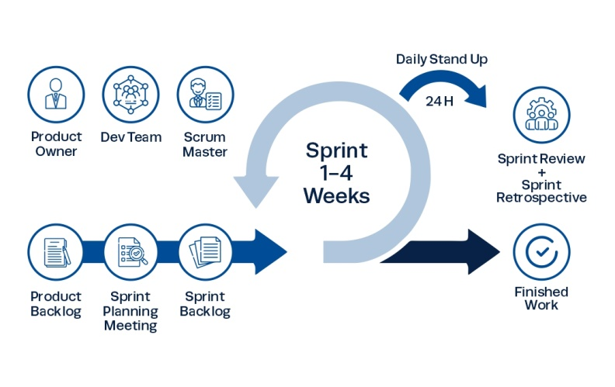
Figure 1: Scrum Process

- Report Organization

The Mentora platform, an AI-driven solution for personalized career and academic planning.

Core Focus:
- Need: Existing online tools for career planning and time management often lack flexibility and true personalization.

- Solution (Mentora): An advanced platform leveraging Artificial Intelligence (AI) to offer hyper-personalized plans.

- Two Modules:

- Career Builder: Generates a comprehensive professional roadmap, including educational paths, certificates, and courses.

- Study Planner: Creates an optimized, personalized study schedule and recommends effective learning methodologies.

Motivation and Technology

- Motivation: To use the OpenAI API to transform user data into clear, customized roadmaps and optimized schedules.

- Technology Stack: Built using a modern, secure stack: React.js (Frontend), ASP.NET Core 9 API (Backend), JWT for authentication, and an SQL Database.

Scope and Methodology

- Scope: Focuses strictly on the Web Application and the two core AI-powered modules (Career Builder and Study Planner).

- Limitations: Excludes native mobile apps, payment integration, real-time course enrollment, live human tutoring, and offline functionality.

- Methodology: Adopted an Agile Approach utilizing the Scrum framework for flexible development and integration with the OpenAI API.

- Gantt Chart

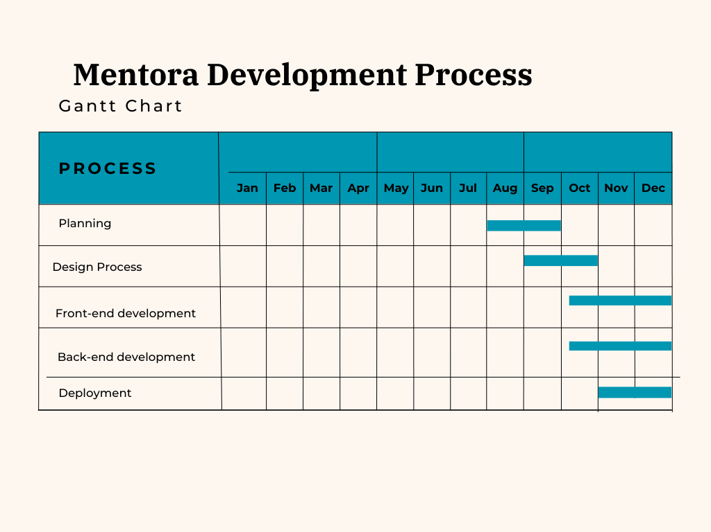
Figure 2: Gantt chart

Chapter 2:

Literature Review/Related Work

  - Overview of Previous Work for Mentora

To achieve the initial vision, an attempt was made to solve the identified challenges in career planning and academic organization, and this is where Mentora comes in. A personalized, intelligent platform is needed to help users effectively plan their professional future, schedule their studies, and gain strategic direction essentially anything required to guide the user towards success using an adaptive, AI-driven application where the limits are the user's aspirations, not the application's rigidity. The following solutions were provided through the core modules:

AI-Powered Career Roadmap Generation: The platform analyzes user input (goals, interests, skills) to automatically generate a detailed professional path. This solution removes the barrier of uncertainty in career planning and offers strategic clarity by detailing required certifications, courses, and educational milestones.

Optimized Study Scheduling and Methodology: Mentora solves time management difficulties by calculating the user’s available hours and generating an optimized, personalized study schedule. It also suggests the most suitable study methodologies (e.g., Pomodoro, spaced repetition) based on the material and the user's learning style.
Although these solutions lead to the feeling that Mentora is a guidance-oriented platform, from the ground up, it was built around the idea of a personalized mentor that can be used by anyone seeking direction and efficiency.

  - Comparative Analysis

- Career Builder Section
This section uses AI to ask users a set of questions to understand their goals and ambitions. It then provides a comprehensive plan for the field they wish to enter , including a proposed career path and key certifications/courses for advancement.

Strengths:

- High Strategic Value: It addresses a critical user need by transforming general ambition into a focused, comprehensive, and actionable career roadmap.

- AI Customization: The use of AI allows the suggested career paths and necessary certifications to be highly customized and relevant to current industry demands and the user's specific input.

- Clarity: Offers a structured guide for professional development, outlining the required steps for progress in a chosen field.

Weaknesses:

- Data Dependency: The quality of the advice is critically dependent on the AI having access to current and accurate labor market data and future industry trends.

- Shallow Input Risk: Relying on a limited set of questions might not capture the full complexity of a user's skills, soft skills, or nuanced career desires.

- Study Planner Section:

This section aims to help users who struggle with time management or finding an effective study method. After gathering information like free time and daily study hours, the system creates a suitable study plan and suggests the optimal study method.

Strengths:

- Addresses a Core Pain Point: Directly tackles the widespread issue of academic time management and study inefficiency.

- Practicality: The plan is built using the user's realistic constraints (available hours and free time), increasing the likelihood of adherence.

- Dual Focus: It provides both a structural plan (when to study) and methodological advice (how to study), maximizing the effectiveness of the user's time.

Weaknesses:

- Compliance Challenge: The AI can generate the plan, but it cannot enforce user adherence, meaning the success still heavily relies on the user's self-discipline.

- Lack of Adaptability: If the system does not dynamically adjust the schedule based on daily deviations (e.g., a missed day of study), the entire plan can quickly become obsolete.

- General Methodologies: The suggested "optimal study method" might be too generalized if it doesn't account for the user's specific learning style or the subject matter being studied.

  - Identified Gaps

- Lack of Integrated Solution: The market suffers from fragmentation, requiring users to switch between separate tools for career mapping, course recommendations, and study schedule management. Mentora addresses this by integrating the Career Builder and Study Planner into one seamless platform.

- Limited Generative AI Integration: While some tools use AI for adaptive scheduling, they do not utilize the powerful generative capabilities of large language models (LLMs) like OpenAI to create entirely new, comprehensive, text-based career narratives, detailed course hierarchies, and personalized study methods from scratch.

- Static Career Path Recommendations: Existing career platforms often provide static or predefined pathways based on large, general datasets. There is a gap for a tool that can instantly tailor a unique professional roadmap based on highly specific, narrative inputs provided by the user (FR1.1).

- Security and Modernity in Integrated Platforms: There is a need for a unified solution built on a modern, secure technology stack (ASP.NET Core 9, JWT) that ensures high performance and security (NFR-S1), which is often a limitation in legacy educational tools.

  - Justification

The development of the Mentora project is necessary and highly beneficial because it directly addresses the critical gaps identified in the current market by offering a novel, unified, and technologically advanced solution.
Mentora is justified because:

- It fills the integration gap: By combining the Career Builder and Study Planner, Mentora eliminates the need for users to manage multiple, disconnected applications, offering a holistic approach to personal development.

- It leverages State-of-the-Art AI: The project's core value is its ability to utilize the OpenAI API to dynamically generate high-quality, customized, and detailed plans (FR1.2, FR2.2). This overcomes the static limitations of competitors and offers truly individualized guidance.

- It prioritizes Security: The choice of ASP.NET Core 9 and JWT authentication (NFR-S1) ensures the platform meets modern enterprise-level security and performance standards, a necessity when handling sensitive personal planning data.

CHAPTER 3:

SYSTEM ANALYSIS & REQUIREMENTS

  - Requirements Gathering

This section aims to identify and document the functional and non-functional requirements essential for the successful delivery of the Mentora project. These requirements form the foundation for the subsequent system design and development.

    - Functional Requirements(FR)

FR-1.0: (User Management & Authentication) The system must provide interfaces for user registration, login, password recovery, and profile management.

FR-1.1: (Career Path Input Collection) The system must provide an interactive questionnaire to collect detailed user inputs regarding career goals, current skills, budget, and time constraints.

FR-1.2: (Career Path Generation) Based on user inputs (FR-1.1), the backend must send a request to the OpenAI API to generate a detailed career roadmap including tentative job titles, required skills, and recommended certifications.

FR-1.3: (Career Path Saving and Retrieval) Users must be able to save generated career paths, retrieve them later, and optionally modify or delete them from the database.

FR-2.1: (Study Planning Input Collection)The system must provide an interface to gather inputs on academic subjects, available free time slots, and required study duration for academic tasks.

FR-2.2: (Optimized Study Plan Generation ) Based on the inputs (FR-2.1), the backend must use the OpenAI API to create an optimized weekly study schedule including recommended study times, task breakdown, and effective learning methods.

FR-2.3:( Visual Study Plan Display) The Frontend must display the generated study plan in a clear visual interface such as a Calendar View or an organized task list.

FR-3.1 (Plan Export ) The system must provide an option to export the generated plans (both Career and Study) in a printable format (e.g., PDF).

    - Non Functional Requirements(NFR)
NFR-S1: (Security) The system must use JWT (JSON Web Tokens) for session protection and guarantee that all data transmission is secure via HTTPS/SSL.
NFR-P1: (Performance (AI Response Time)) The system response time from the moment an AI generation request (FR-1.2/FR-2.2) is sent until the final result is displayed must not exceed 10 seconds (excluding external OpenAI API latency).
NFR-P2: (Scalability) The backend (ASP.NET Core 9) must be capable of handling a minimum of 100 concurrent users without noticeable degradation in performance.
NFR-U1: (Usability) The User Interface (built with React.js and Tailwind) must be intuitive, consistent, and responsive across various devices.
NFR-M1: (Maintainability) The codebase must be written according to standard conventions (Clean Code) with clear API documentation to allow for easy future modifications and updates.

  - Stakeholder Analysis

Based on the previously introduced method of analysis, a group of stakeholders essential for the success of the platform, Mentora, was identified. Some of the most important stakeholders are:

- End User / Student
- Role:
- Individuals seeking academic and professional guidance.

- Students and professionals who need to build a career path and organize their studies.

- They provide fundamental data (like goals, ambitions, free time, and available study hours).
- Impact:
- Their satisfaction with the generated plans and advice determines the product's success.

- They validate the accuracy and usefulness of the proposed career paths and the suitability of the study schedules.

- Their feedback helps prioritize future development for improving the planning and guidance algorithms.

- Development Team
- Role:
- Developers: Build and maintain the application using the chosen stack: React.js, ASP.NET Core 9 API, C#, and SQL.

- Ensure system security using JWT Authentication and manage database operations.

- Develop the logic to send and handle POST requests between the backend and the OpenAI API.
- Impact:
- They are responsible for the system's performance, scalability, and stability.

- Their work directly controls the speed and reliability of delivering the AI-generated plans to the user.

- Accountable for testing and documentation.

- AI / Technical Integration Team
- Role:
- Manage and configure the connection to the OpenAI API.

- Ensure the AI processes user inputs (goals, time constraints) correctly to generate high-quality outputs (integrated career plan, optimized study schedule).
- Impact:
- They determine the core value of the Mentora project by ensuring the intelligence and personalization of the plans generated.

- The quality and relevance of the suggested certifications, courses , and optimal study methods are directly dependent on their implementation.

- Product Owner / Project Manager

- Role:
- Define the project's vision: to develop the user's academic and professional life using AI.

- Oversee development timelines and resource allocation.

- Prioritize feature additions and improvements for the Career Builder and Study Planner sections.

- Impact:
- Guides the entire team and ensures the product's features align with solving the target problems (career guidance, time organization).

- Their decisions determine whether the final application successfully meets its comprehensive planning and organizational goals.

  - Use Case Diagrams
A use case diagram visually represents the potential interactions between users and an application. This graphical depiction showcases different use cases and user types associated with the application, typically accompanied by additional diagrams for a comprehensive understanding. Use cases are illustrated by circles or ellipses, while users are symbolized as stick figures in the diagram.

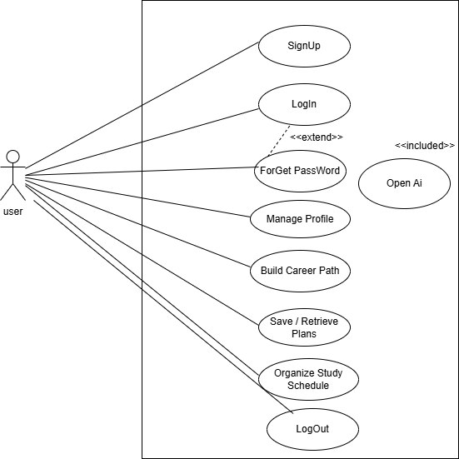
Figure 3: use case digram

  - User Stories / Requirements Table

    - User SignUp
As a new user, I want to sign up and create a secure account so that I can access Mentora's features.

    - User Login
As a returning user, I want to log in securely so that I can access my saved plans and profile.

    - ForGet Password
As a user, I want to recover my password if I forget it, so that I don't lose access to my account.

    - Profile Management
As a user, I want to manage and update my profile information so that my data is accurate.

    - Career Input
As a user, I want to input my career goals, skills, budget, and time constraints through an interactive questionnaire so that the AI can understand my needs.

    - Career Path Generation
As a user, I want the system to generate a detailed career roadmap (job titles, skills, certifications) using AI so that I have a clear path to follow.

    - Save/Retrieve Career Path
As a user, I want to save, retrieve, modify, or delete my generated career path so that I can track my progress and refer to it later.

    - Study Input
As a user, I want to input my academic subjects, free time, and required study duration so the system can plan my schedule.

    - Study Plan Generation
As a user, I want the system to create an optimized weekly study schedule (times, tasks, and methods) using AI so that I can manage my time effectively.

    - Visual Plan Display
As a user, I want to view my study plan in a clear visual interface (Calendar View/List) so that it is easy to follow.

    - Plan Export
As a user, I want to be able to export my generated plans (Career and Study) in a printable format (e.g., PDF) so that I can have an offline copy.

  - Tools and Technologies

    - Technologies

Hyper Text Markup Language (HTML)
It is a fundamental language for web development. HTML elements are used by developers to structure various components such as forms, headings, paragraphs, images, and hyperlinks. These elements determine a webpage's content layout and organization. It is commonly combined with JavaScript for interactivity and CSS
for styling. Web developers can build responsive and accessible web pages by following official guidelines and best practices.

Cascading Style Sheet (CSS)
It is a styling language for HTML documents. It defines how elements should look and behave on different screens and in print. Web developers can control colors, fonts, spacing, and page layout using CSS. It simplifies updating and maintaining a website's visual appearance by separating style from content.

JavaScript (JS)
It is a dynamic programming language that enables a wide range of functionalities, including handling multimedia, creating animations, and updating content dynamically. We utilized it for interactive and dynamic content.
React.js
React is an open-source JavaScript library by Meta for building user interfaces, especially single-page applications (SPAs). It uses a component-based architecture with reusable UI components that manage state. React’s virtual DOM efficiently updates and renders changes, improving performance. It follows declarative programming, where developers define the UI while React handles rendering. Features like hooks simplify state and side effect management. React is popular for its scalability, flexibility, and extensive ecosystem, making it ideal for dynamic web applications.
Node.js
Node.js is an open-source, cross-platform runtime environment that allows JavaScript code to be executed outside of a web browser (server-side). Building highly scalable, data-intensive, and real-time network applications (like APIs and chat servers). It utilizes a non-blocking, event-driven architecture, making it highly efficient for handling numerous concurrent connections.

    - Editors and other tools:
draw.io
It is a free online tool used to create charts and diagrams such as flowcharts, network diagrams, engineering drawings, UML diagrams, and other types of diagrams. Users can use draw.io to design and create visual diagrams to illustrate processes, systems, or ideas.

Figma
With the help of the cloud-based design tool Figma, team members can quickly design, prototype, and collect feedback in one location. Figma is the first browser-based interface design tool that simplifies software creation for teams.

Tailwind CSS
Tailwind CSS is a utility-first CSS framework that provides low-level, pre-defined classes for building custom user interfaces directly within HTML. It emphasizes flexibility by allowing developers to combine classes to create unique designs without writing traditional CSS. Tailwind offers responsive design features, pseudo-class variants, and utility modifiers that simplify complex styling tasks. It improves development speed by reducing the need to switch between CSS and HTML files, ensuring a consistent and maintainable codebase. Tailwind CSS is widely used for building modern and responsive web applications.

Visual Studio Code (VS Code)
Visual Studio Code is a source-code editor developed by Microsoft, widely regarded for its versatility and performance. It supports multiple programming languages and offers features such as syntax highlighting, intelligent code completion, debugging, and version control integration.

GIT
Git is a distributed version control system crucial in software development. It tracks changes in source code, facilitating collaboration among developers. With features like branching and merging, Git enables concurrent work on projects. Hosting platforms like GitHub make it easy to share and manage code collaboratively.

GitHub
GitHub is a web-based platform that allows developers to host and manage code repositories, track changes, and collaborate through features such as pull requests, issue tracking, and branching. GitHub enhances team productivity by enabling code reviews, continuous integration (CI), and automated workflows through GitHub Actions. GitHub is a crucial tool for managing software development projects of all sizes.

ASP.NET Core 9
is a free, open-source, and high-performance framework from Microsoft. A robust framework used for building modern backends and Web APIs. Primarily uses the C# programming language. Highly performant and cross-platform (runs on Windows, Linux, and macOS).

JSON Web Token(JWT)
It is a secure, standard way to transmit information between two parties as a JSON object. It is widely used in modern web applications, particularly with API services. JWT is utilized in the Mentora project for Authentication. This means it helps secure the user session and verifies the user's identity on every request they send to the Backend. It ensures that the logged-in user is indeed who they claim to be.

SQL server
(correctly spelled SQL Server) is the name of a relational database management system (RDBMS) developed and marketed by Microsoft. A Microsoft Relational Database Management System (RDBMS) used for secure, organized, and scalable storage of data.

  - Regulatory / Ethical Considerations
The "Mentora" project, especially given its collection of personal data and utilization of Artificial Intelligence, demands strict adherence to privacy policies, cybersecurity practices, and ethical standards.
- Data Privacy and Security Policies
Given the collection of user data (e.g., goals, free time, career aspirations ) to generate personalized plans, strong policies must be implemented:
- Data Encryption:
- All sensitive user data stored in the SQL Database (Data At Rest) must be encrypted.

- Secure protocols (like HTTPS/SSL) must be used to encrypt data during transit between the Frontend (React.js ) and the Backend (ASP.NET Core 9 API ).

- Authentication and Authorization:
- JWT (JSON Web Tokens) must be used for secure user authentication to protect sessions and verify identity.

- Data Minimization: Only the minimum necessary data should be collected to operate the core project units (Career Builder and Study Planner. ).

- Ethical Concerns and Artificial Intelligence (AI)
Reliance on the OpenAI API to generate career paths and study schedules introduces specific ethical responsibilities:

- Transparency and Bias:
- Bias Mitigation: The AI outputs must be monitored to ensure recommendations are not biased based on gender, race, or social background when suggesting career paths.

- AI Disclosure: Users must be clearly informed that the plans provided are AI-generated recommendations and not definitive decisions.

- Accountability: Despite using an external tool (OpenAI API), the project remains accountable for the quality and security of the data sent to and received from the service.

- Data Security: The connection between the Backend (C# ) and the OpenAI API must be secured (e.g., by using protected API keys).

- Cybersecurity Requirements

To enhance cybersecurity:

- Error Handling: Error messages from the Backend (ASP.NET Core 9 API) must be generic and must not disclose sensitive system details to potential attackers.

- Principle of Least Privilege (PoLP): Users should only be granted the minimum permissions required for their specific functions (Read/Write/Update/Delete) to minimize risk exposure.

Chapter 4:
DESIGN

  - System Architecture

- Logical Architecture

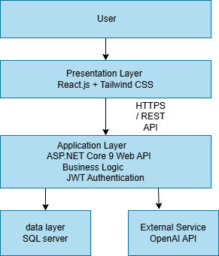
Figure 4: Logical Architecture Digram
Description:
The logical architecture of the Mentora system follows a layered (three-tier) architecture. The presentation layer handles user interaction through a React.js web interface. The application layer manages business logic, authentication, and AI communication. The data layer is responsible for storing and retrieving system data. The OpenAI API is integrated as an external service to generate personalized career and study plans.

- Physical Architecture

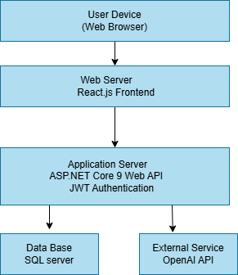
Figure 5: Phisical Architecture Digam
Description:
The physical architecture represents the deployment environment of the Mentora system. Users access the system through a web browser. The frontend is hosted on a web server, while the backend API and database are deployed on separate servers. The system communicates securely with the external OpenAI API to generate AI-driven content.

  - Data Flow / ER Diagrams
- Data Flow digram:

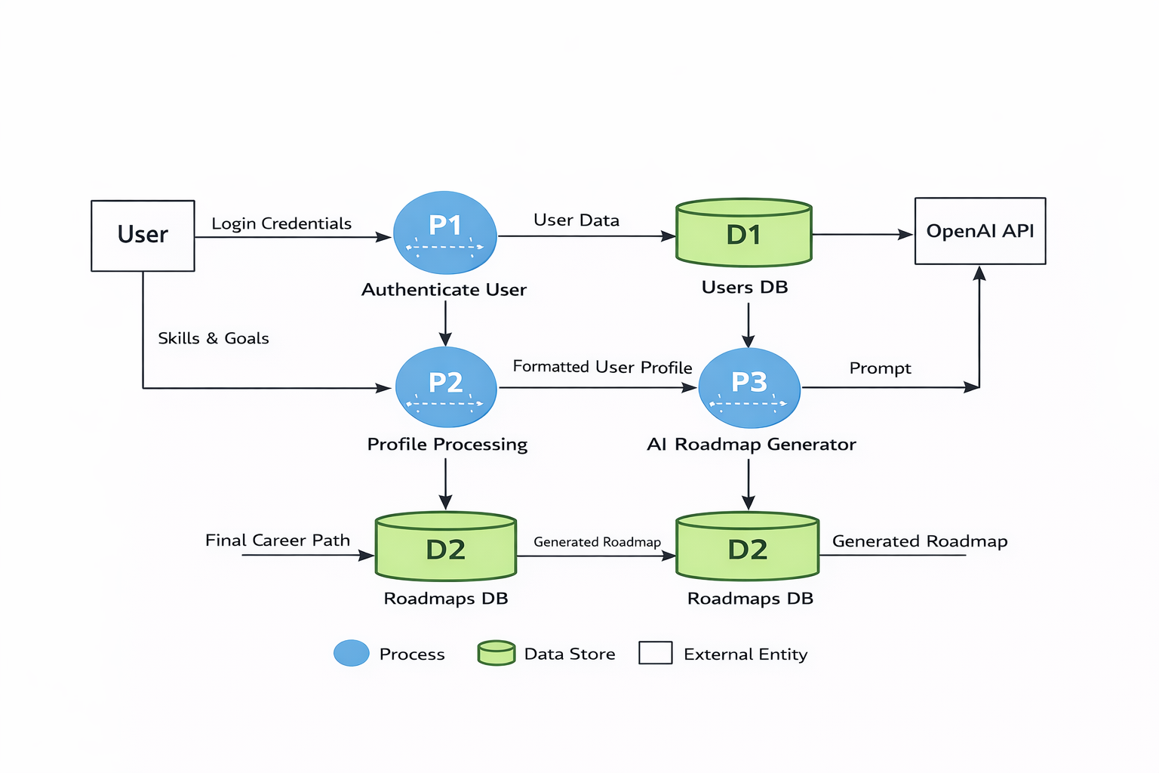
Figure 6:DataFlow digram

- ER digram:

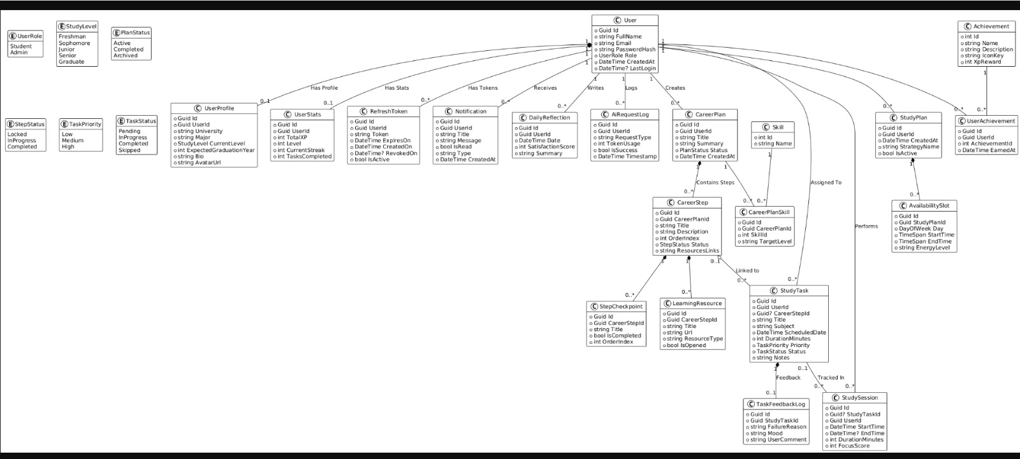
Figure 7: ER Digram

  - Database Design

- Schemas:

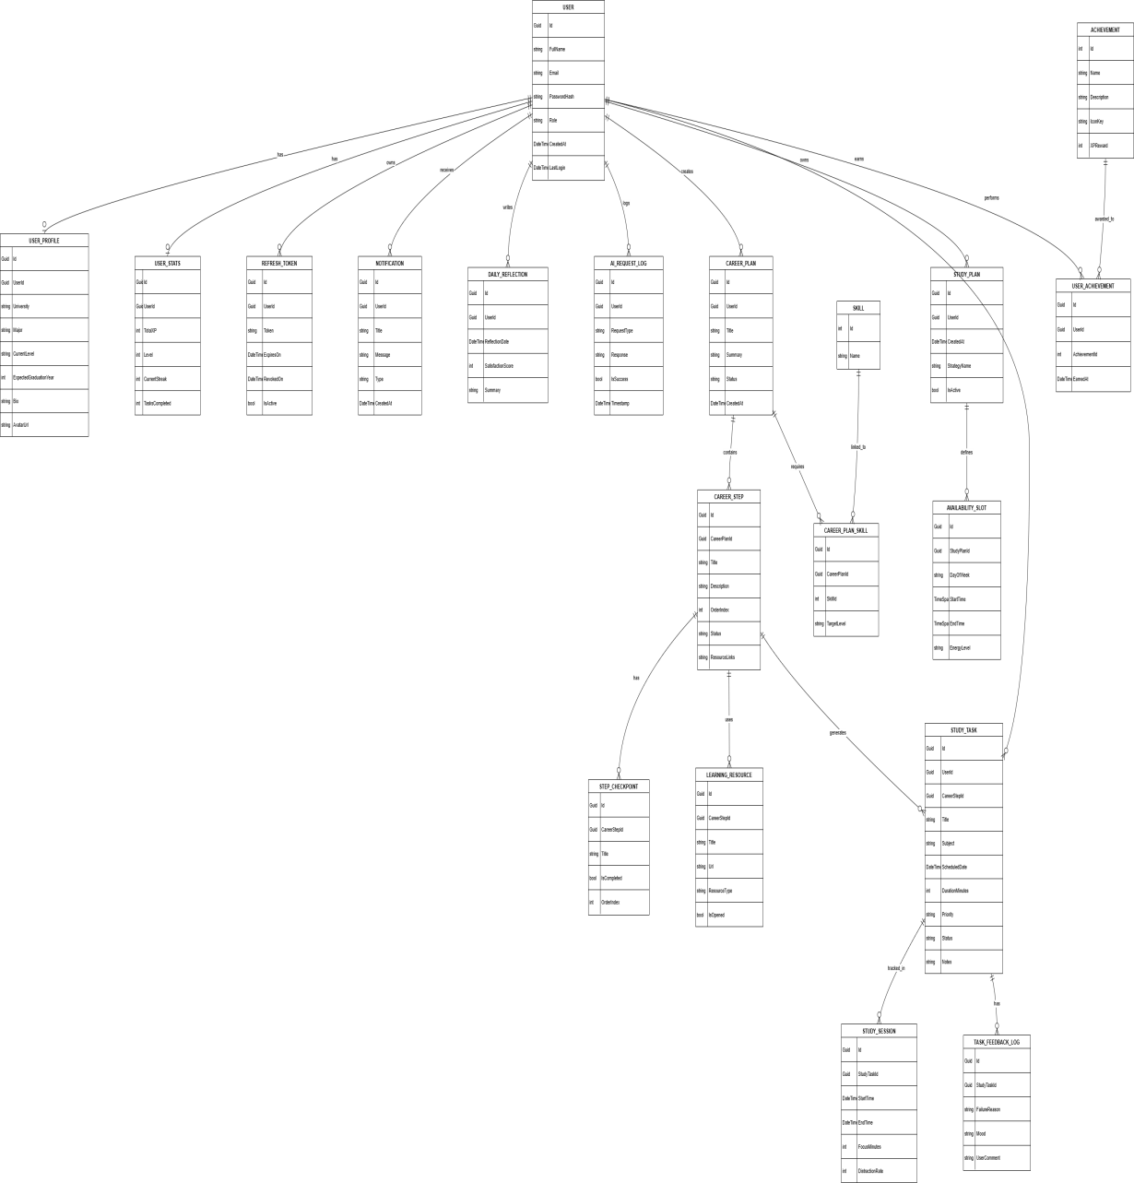
- Table structures:
User Table

Column | Data Type | Description
Id | GUID | Primary Key
Full name | NVARCHAR(255) | Full Name
Email | NVARCHAR(255) | Email address
PasswordHash | NVARCHAR(255) | Encrypted Password
Role | NVARCHAR(50) | User Role (Student/Admin)
CreatedAt | DATETIME | Account Creation Date
LastLogin | DATETIME | Last Login Date
Table 1:Users

UserProfile

Column | Data Type | Description
Id | GUID | Primary Key
User Id | GUID | User ID (Foreign Key)
University | NVARCHAR(255) | University Name
Major | NVARCHAR(255) | Major/Field of Study
StudyLevel | NVARCHAR(50) | Study Level (Freshman, Sophomore, etc.)
ExpectedGraduation year | INT | Expected Graduation Year
AvatarUrl | NVARCHAR(MAX) | Profile Picture URL
Table 2:UserProfile

User state
Column | Data Type | Description
Id | GUID | Primary Key
UserId | GUID | User ID (Foreign Key)
TotalXP | INT | Total Experience Points
Level | INT | Current Level
CurrentStreak | INT | Streak Count
TasksCompleted | INT | Number of Completed Tasks
Table 3:User state
Refresh Token
Column | Data Type | Description
Id | GUID | Primary Key
UserId | GUID | User ID (Foreign Key)
Token | NVARCHAR(MAX) | Refresh Token
ExpiresOn | DATETIME | Expiration Date
RevokedOn | DATETIME | Revoked Date (optional)
IsActive | BIT | Token Active Status
Table 4:Refresh Token

Column | Data Type | Description
Id | GUID | Primary Key
UserId | GUID | User ID (Foreign Key)
Title | NVARCHAR(255) | Notification Title
Message | NVARCHAR(MAX) | Notification Message
IsRead | BIT | Read Status
Type | NVARCHAR(50) | Notification Type
CreatedAt | DATETIME | Date Created
Table 5:Notification

DailyReflection
Column | Data Type | Description
Id | GUID | Primary Key
UserId | GUID | User ID (Foreign Key)
SatisfactionScore | INT | Daily Satisfaction Score
Summary | NVARCHAR(MAX) | Reflection Summary
CreatedAt | DATETIME | Date Created
Table 6:Daily Refliction

AI Request Log
Column | Data Type | Description
Id | GUID | Primary Key
UserId | GUID | User ID (Foreign Key)
RequestType | NVARCHAR(100) | Type of AI Request
TokenUsage | INT | Tokens Used
IsSuccess | BIT | Request Success Status
Timestamp | DATETIME | Request Timestamp
Table 7:AI Request Log

Career Plan
Column | Data Type | Description
Id | GUID | Primary Key
UserId | GUID | User ID (Foreign Key)
Title | NVARCHAR(255) | Plan Title
Summary | NVARCHAR(MAX) | Plan Summary
PlanStatus | NVARCHAR(50) | Active, Completed, Archived
CreatedAt | DATETIME | Date Created
Table 8:CareerPlan
Career Step
Column | Data Type | Description
Id | GUID | Primary Key
CareerPlanId | GUID | Career Plan ID (Foreign Key)
Title | NVARCHAR(255) | Step Title
Description | NVARCHAR(MAX) | Step Description
OrderIndex | INT | Step Order
StepStatus | NVARCHAR(50) | Locked, InProgress, Completed
ResourcesLinks | NVARCHAR(MAX) | Related Resource Links
Table 9:Career Step

StepCheckPoint
Column | Data Type | Description
Id | GUID | Primary Key
CareerStepId | GUID | Career Step ID (FK)
Title | NVARCHAR(255) | Checkpoint Title
IsCompleted | BIT | Completion Status
OrderIndex | INT | Checkpoint Order
Table 10:Step Check Point
Learning Resource
Column | Data Type | Description
Id | GUID | Primary Key
CareerStepId | GUID | Career Step ID (FK)
Title | NVARCHAR(255) | Resource Title
Url | NVARCHAR(MAX) | Resource URL
ResourceType | NVARCHAR(100) | Resource Type
IsOpened | BIT | Opened Status
Table 11: Learning Resource
Skill
Column | Data Type | Description
Id | GUID | Primary Key
Name | NVARCHAR(255) | Skill Name
Table 12:Skill

Column | Data Type | Description
Id | GUID | Primary Key
CareerPlanId | GUID | Career Plan ID (FK)
SkillId | GUID | Skill ID (FK)
TargetLevel | INT | Target Level for Skill
Table 13: Career Plane Skills

Column | Data Type | Description
Id | GUID | Primary Key
UserId | GUID | User ID (FK)
StrategyName | NVARCHAR(255) | Strategy Name
CreatedAt | DATETIME | Date Created
IsActive | BIT | Active Status
Table 14:Study Plan

StudyTask
Column | Data Type | Description
Id | GUID | Primary Key
UserId | GUID | User ID (FK)
CareerStepId | GUID (Optional) | Career Step ID (FK)
Title | NVARCHAR(255) | Task Title
Subject | NVARCHAR(255) | Task Subject
ScheduledDate | DATETIME | Scheduled Date
DurationMinutes | INT | Duration in Minutes
Priority | NVARCHAR(50) | Low, Medium, High
Status | NVARCHAR(50) | Pending, InProgress, Completed, Skipped
Notes | NVARCHAR(MAX) | Task Notes
Table 15:StudyTask

Column | Data Type | Description
Id | GUID | Primary Key
StudyTaskId | GUID | Study Task ID (FK)
FailureReason | NVARCHAR(MAX) | Reason for Failure
Mood | NVARCHAR(100) | Mood
UserComment | NVARCHAR(MAX) | User Comments
Table 16: Task Feedback Log

Column | Data Type | Description
Id | GUID | Primary Key
StudyTaskId | GUID | Study Task ID (FK)
UserId | GUID | User ID (FK)
StartTime | DATETIME | Session Start Time
EndTime | DATETIME | Session End Time
DurationMinutes | INT | Duration in Minutes
FocusScore | INT | Focus Score
Table 17: Study Session

Column | Data Type | Description
Id | INT (Auto) | Primary Key
Name | NVARCHAR(255) | Achievement Name
Description | NVARCHAR(MAX) | Achievement Description
IconKey | NVARCHAR(255) | Icon Key
XpReward | INT | XP Reward
Table 18:Achevement

Column | Data Type | Description
Id | GUID | Primary Key
UserId | GUID | User ID (FK)
AchievementId | INT | Achievement ID (FK)
EarnedAt | DATETIME | Date Earned
Table 19:User Achevement

Column | Data Type | Description
Id | GUID | Primary Key
StudyPlanId | GUID | Study Plan ID (FK)
DayOfWeek | NVARCHAR(50) | Day of the Week
StartTime | TIME | Start Time
EndTime | TIME | End Time
EnergyLevel | NVARCHAR(50) | Energy Level
Table 20:AvailabilitySlot

  - UI/UX Prototypes
wireframes


Figure 8:Home Page

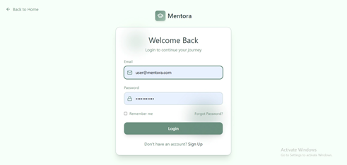
Figure 9:Login
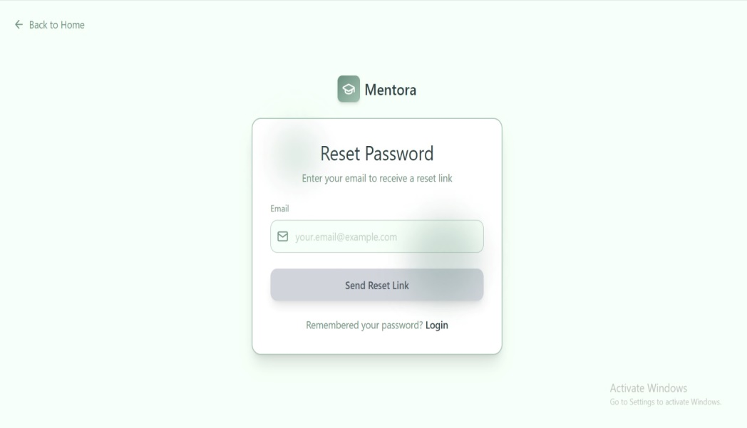
Figure 10:ForGet Password

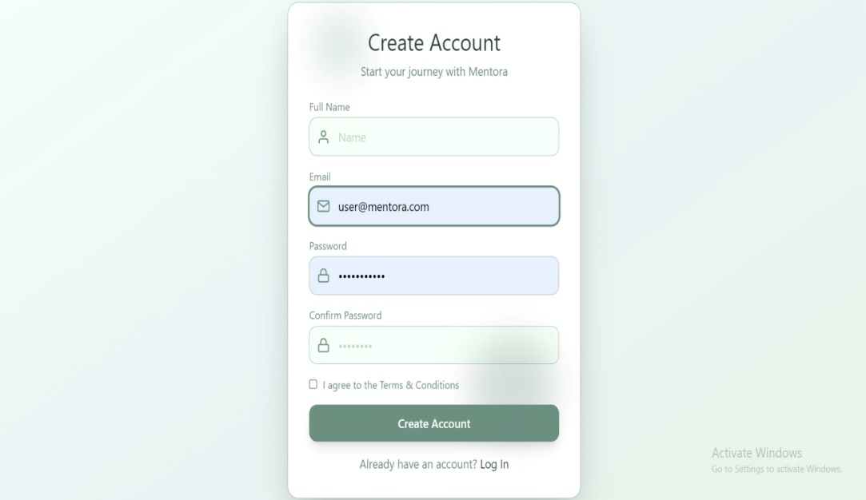
Figure 11:SignUp

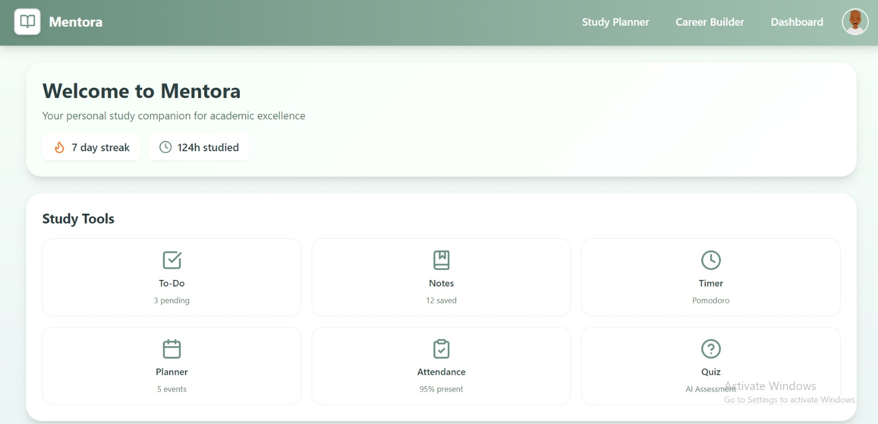
Figure 12:FirstPage

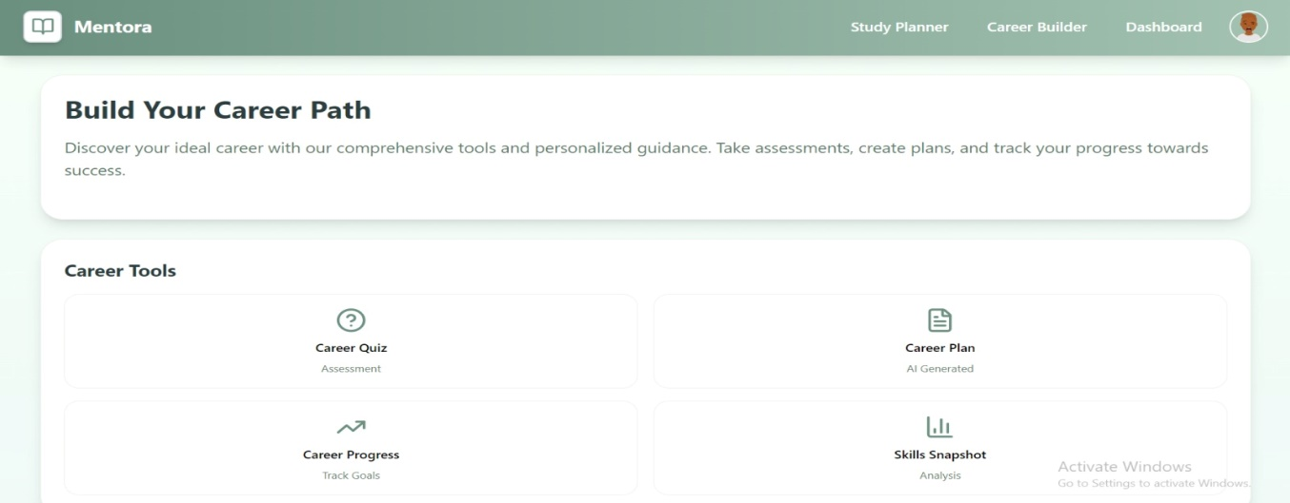
Figure 13:Career builder

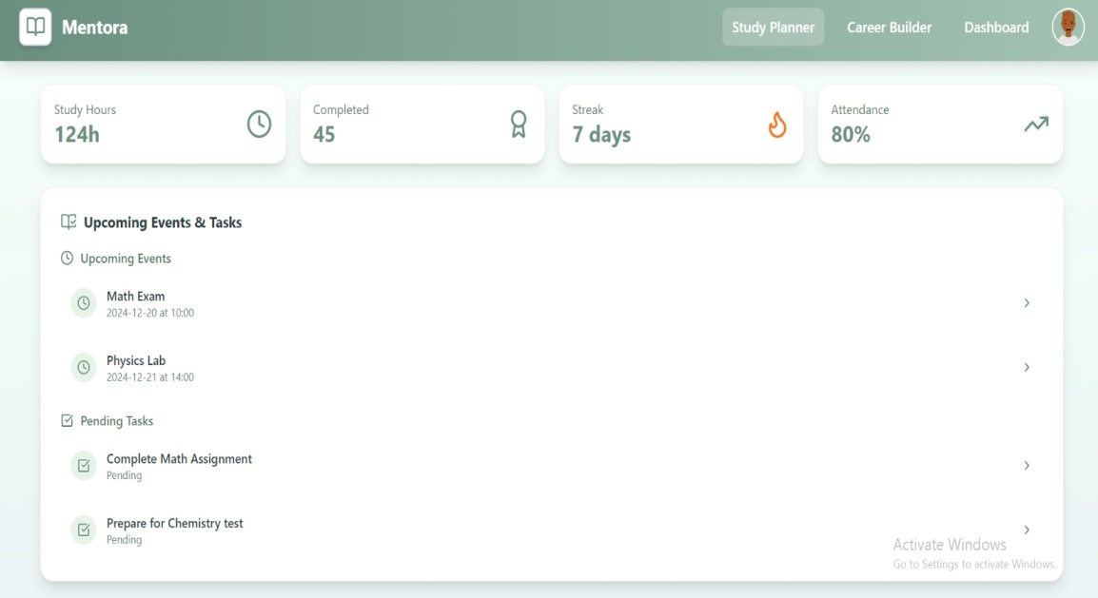
Figure 14:DashBoard

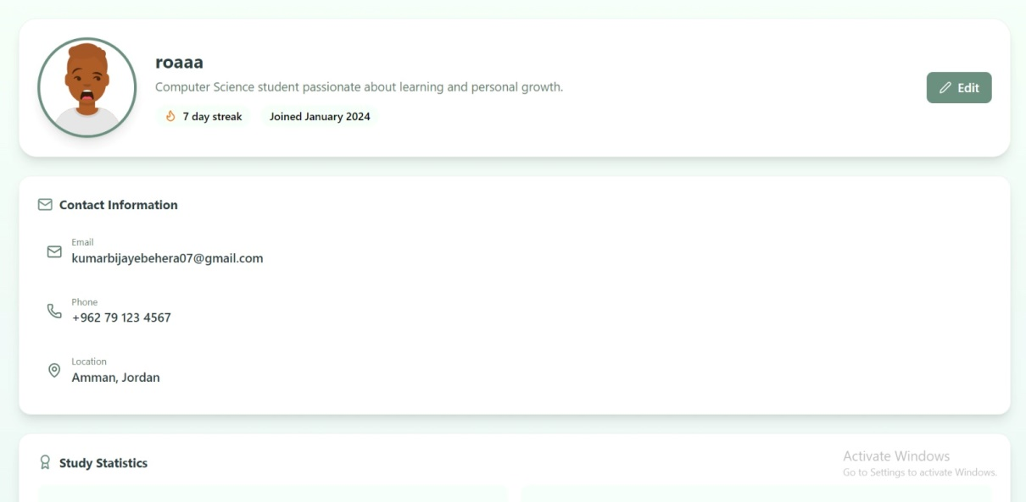
Figure 15:Profile Page

  - Security Design
The security design for Mentora is implemented to protect sensitive user data, intellectual property (AI roadmaps), and system integrity. Below are the key security layers integrated into the system:

- Authentication and Password Security:
To ensure that only authorized users can access the system, a robust authentication mechanism is implemented:

- Password Hashing: Passwords are never stored in plain text. Instead, they are hashed using the BCrypt algorithm before being saved in the PasswordHash field of the Users table. This ensures that even if the database is compromised, the actual passwords remain unreadable.

- Secure Session Management: The system utilizes JSON Web Tokens (JWT) for session handling. Upon a successful login, the server issues an AccessToken and a RefreshToken, allowing for secure, stateless communication.

- Role-Based Access Control (RBAC)
Access to system features is strictly governed by user roles to prevent unauthorized data access:
- User Roles: As defined in the UserRole enum, the system distinguishes between Students and Admins.
- Authorization Logic: Students can only view and modify their own CareerPlan and StudyTask records. Admins have higher-level access to monitor AIRequestLogs and manage system-wide data without accessing private user reflections.

- Data Privacy and Integrity:
Protecting the data in transit and at rest is a priority:

- Transport Layer Security (TLS): All communications between the mobile application and the backend server are encrypted using HTTPS to prevent "Man-in-the-Middle" (MITM) attacks.

- Input Validation: To protect against SQL Injection and Cross-Site Scripting (XSS), all user inputs (such as Bio, Task titles, and Career goals) are sanitized and validated on the server side before processing.

- AI Infrastructure Security:
Since the core value of Mentora lies in its AI integration, specific measures are taken to protect AI resources:
- API Key Protection: AI service keys (e.g., OpenAI keys) are stored securely on the server environment and are never exposed to the client-side code.

- Usage Monitoring: Every interaction is logged in the AIRequestLog. This allows the system to detect unusual patterns, such as a high volume of requests from a single user, which could indicate an attempt to abuse the system's resources.

  - AI Model Architecture
The AI engine of Mentora is designed to provide personalized career roadmaps and optimized study schedules. The architecture follows a Large Language Model (LLM) integration pattern, specifically utilizing models like GPT-4 or Gemini via secure API requests.

- Model Information:

- Model Type: Generative Pre-trained Transformer (LLM).
- Integration Method: RESTful API via a secure backend proxy to protect API keys.
- Logging: Every interaction is tracked in the AIRequestLog table, monitoring TokenUsage and RequestType.

- Input Data (Prompt Engineering):
The model receives structured inputs from the user to ensure accurate results. These inputs are gathered from:
- User Profile Data: Major, University, and Study Level.
- Career Inputs: User goals, existing skills, and time constraints.
- Study Inputs: Subject names, task priorities, and duration.

- Architecture Layers:
- Application Layer: Collects user raw data (e.g., "I want to be a Data Scientist").

- Preprocessing Layer (Prompt Template): Transforms raw data into a technical prompt (e.g., "Act as a career coach, create a roadmap for a [Major] student with these [Skills]...").

- Inference Layer (Cloud AI): The LLM processes the prompt and predicts the best sequence of CareerSteps and LearningResources.

- Post-processing Layer: The AI's JSON output is parsed and mapped into the database tables (e.g., CareerPlan and StudyTask).

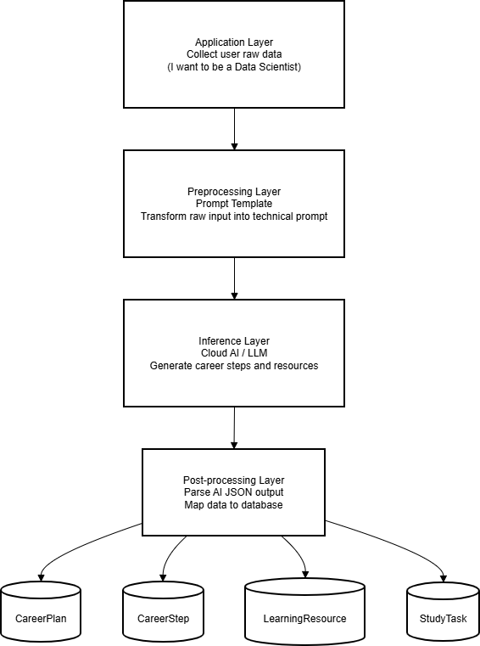
Figure 16:Architecture Layers of Ai

- AI Monitoring and Feedback Loop:

The system implements a feedback mechanism to improve model reliability:
- Success Tracking: The IsSuccess boolean in AIRequestLog monitors if the AI generated a valid response.

- User Feedback: When a task is failed or skipped, the TaskFeedbackLog records the reason, which can be fed back to the AI to adjust future study plans for better personalization.

  - UML Diagrams

    - Class Diagrams

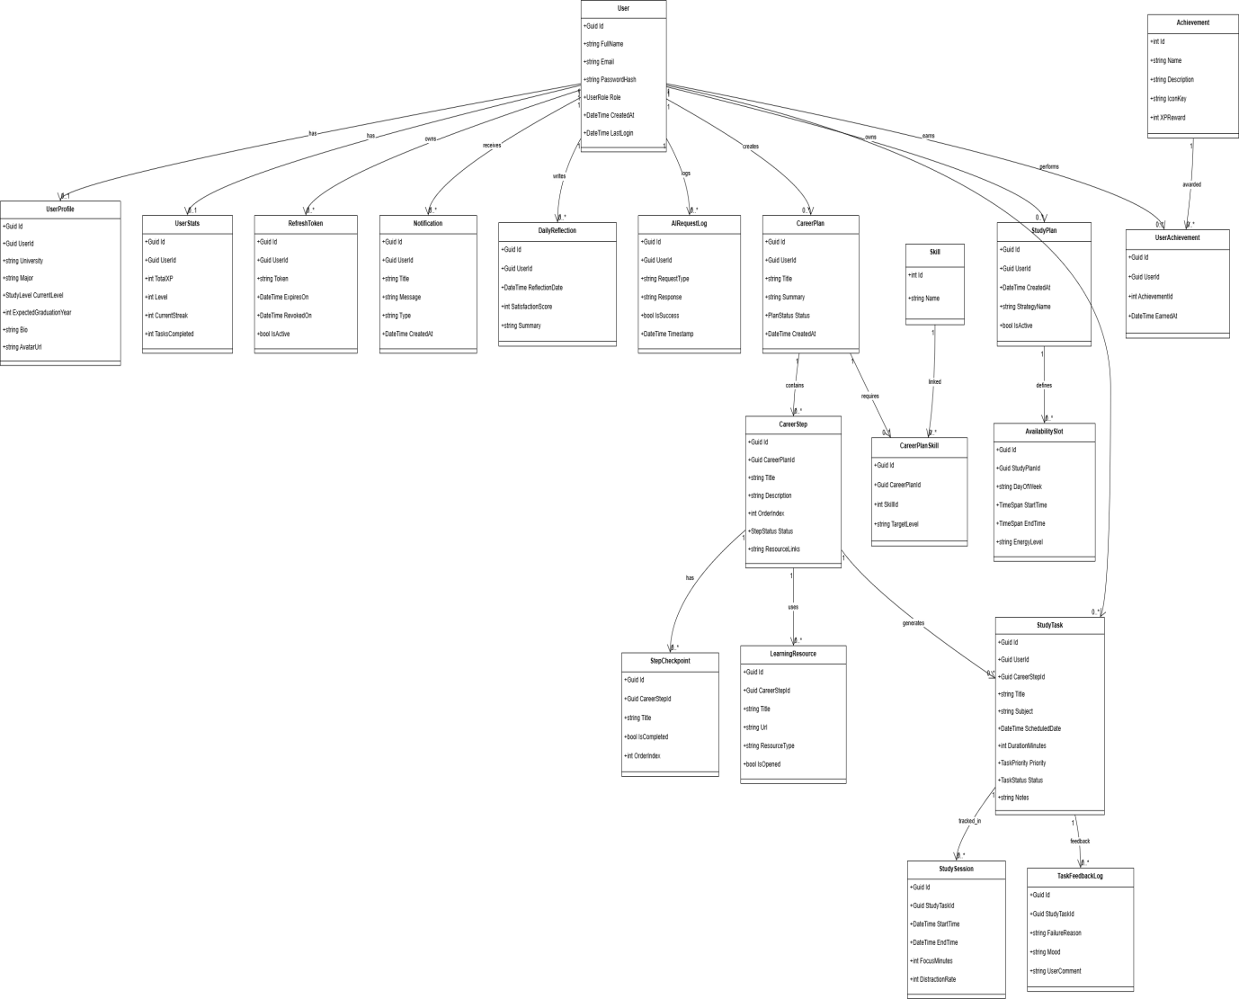
Figure 17:ClassDigram
    - Sequence Diagrams
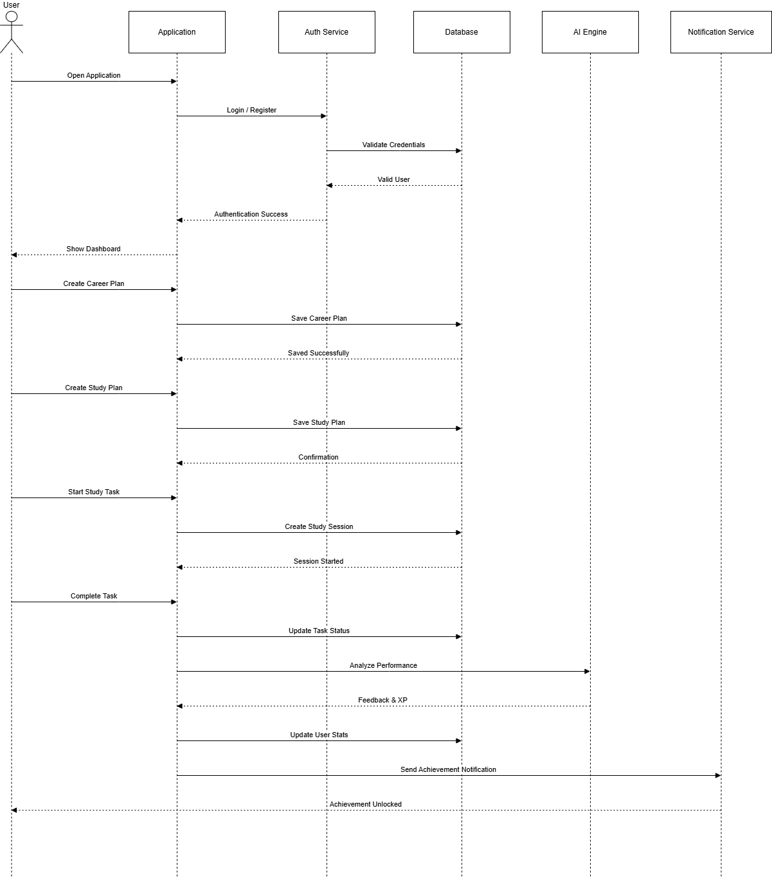
Figure 18:Sequence Digrams

    - Activity Diagrams
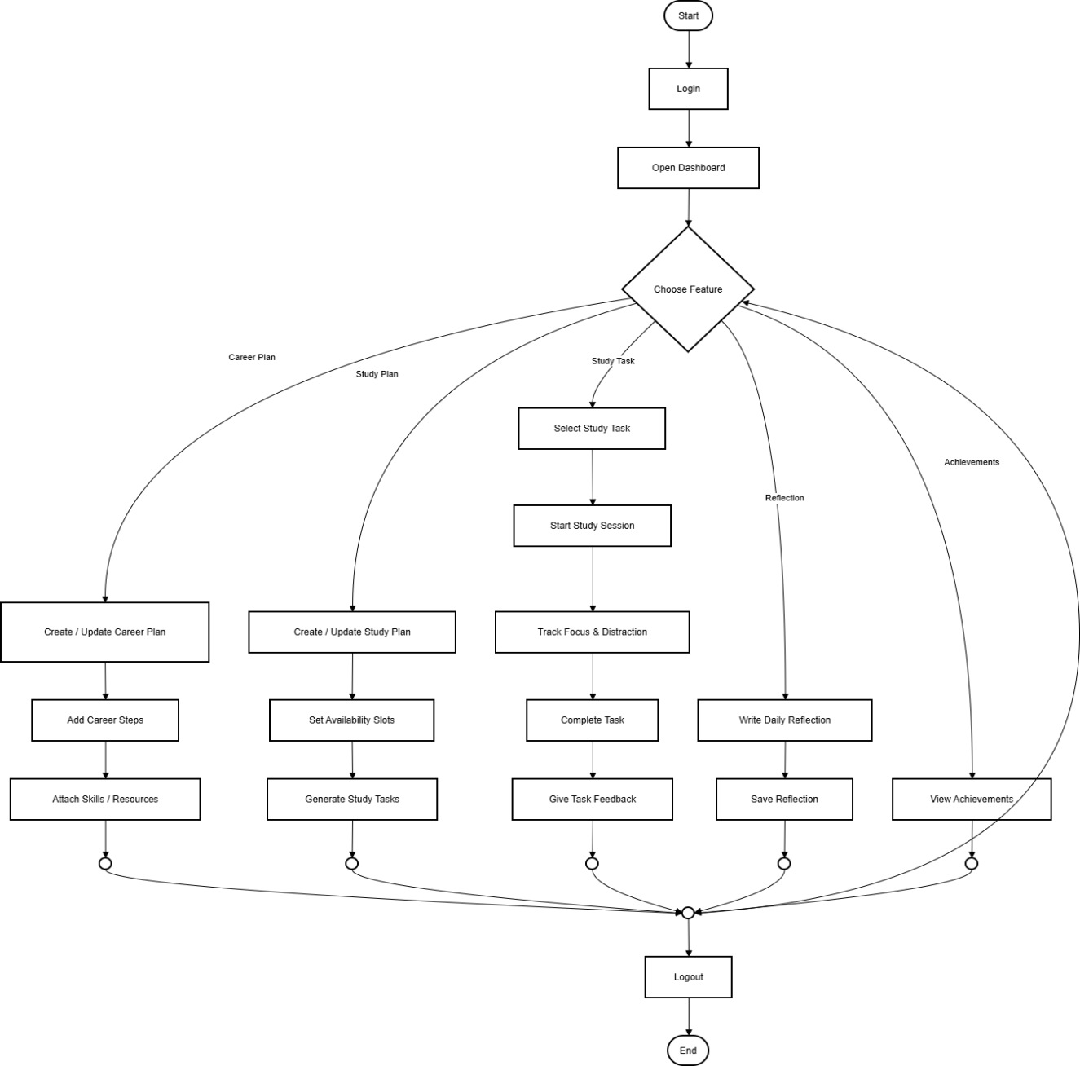
Figure 19:Activity Digram

Chapter 5:
Implementation

  - Tools,Platforms,Framework

    - Frameworks &Libraries
Node.js: is primarily driven by its event-driven and non-blocking I/O architecture which is exceptionally efficient for handling asynchronous operations such as the long-running API calls required by generative AI models. This ensures that the server remains responsive to multiple concurrent student requests while waiting for AI-generated roadmaps. Additionally the use of Node.js allows for a unified JavaScript development stack when paired with React.js on the frontend which significantly streamlines the development lifecycle improves team productivity and ensures high scalability for data-intensive real-time applications.
React: determines most of the syntax, because Next.js is a framework built on top of React, so the hierarchy here is JavaScript, React on top, and then Next is the topmost level.
Tailwind: it is a set of a huge list of CSS classes applied already and ready to use, it simplifies and fastens the development process, by using already built CSS classes.
    - Tools:
Visual Studio Code: A lightweight code editor for efficient development, where the use of extensions powers our development process, like Prettier.

Draw.io: Used to design database schemas and make UML diagrams.
Figma: it was the main way to design the UI/UX for Mentora, and to make the theme.

Github: facilitates version control and collaboration between developers, ensuring seamless code management.

Git: it is a distributed version control system that is combined with GitHub to make versions and collaborate with the team on the project.
  - Code Structure
The project is organized into two main directories: Frontend and Backend. This separation ensures a "Separation of Concerns" (SoC), making the system easier to maintain, test, and scale.

    - Frontend Structure (React.js)
The frontend follows a component-based modular structure:

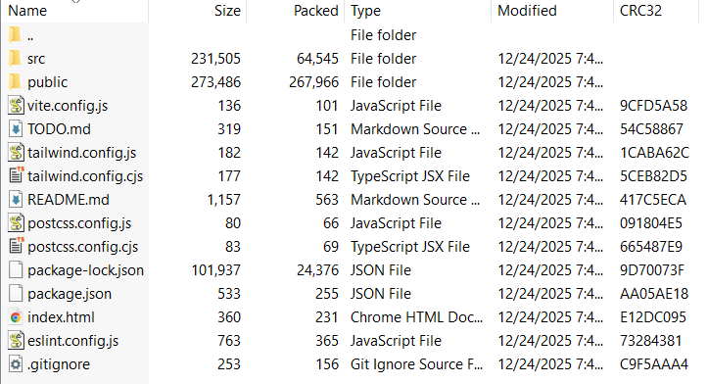
Figure 20:Frontend structure
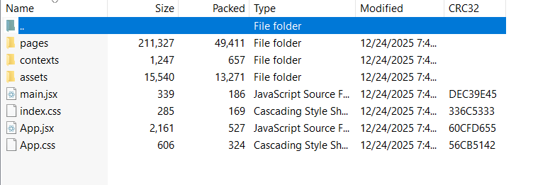
Figure 21:Frontend src

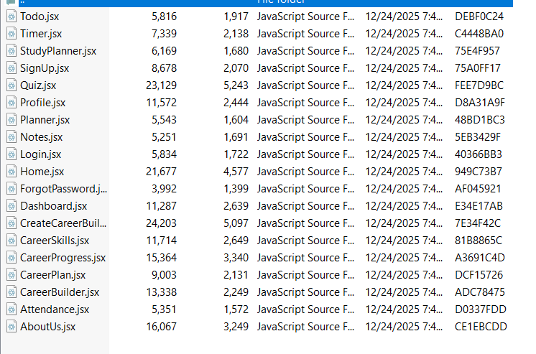
Figure 22:Frontend pages

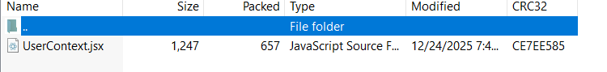
Figure 23: Frontend Context
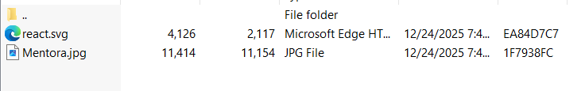
Figure 24:Frontent asest

    - Backend Structure (ASP.NET Core / Node.js)
The backend is structured according to the Layered Architecture or MVC pattern:
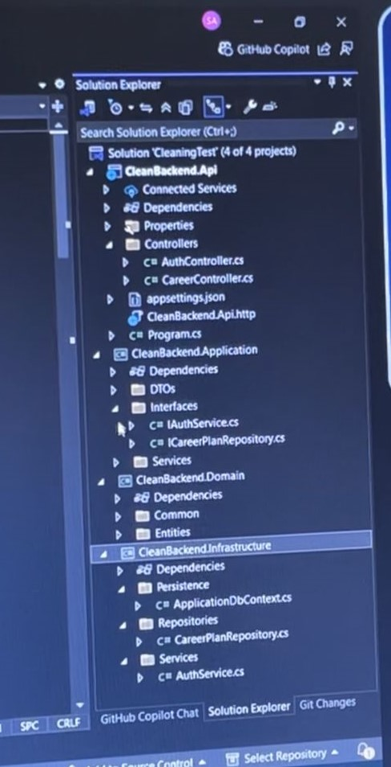
Figure 25:Backend Structure

  - Key Modules / Components
The Mentora platform is organized into several high-level modules that work together to provide an intelligent, gamified academic and career planning experience. Each module translates complex user data into actionable insights through backend logic and AI integration.

- Authentication and Security Module
This module manages the entry point to the application, ensuring that all user data remains private and secure.

- Registration & Login: Users can create an account by providing their full name, email, and a secure password.

- Identity Verification: The login interface validates credentials against the SQL Server database.

- Password Recovery: Includes a "Reset Password" feature that allows users to receive a reset link via their registered email.

- Security Standard: Implements JWT (JSON Web Tokens) to authorize every request, ensuring only the logged-in user can access their specific dashboard and tools.

- AI Career Roadmap Engine
Located within the "Career Builder" section, this module utilizes Artificial Intelligence to bridge the gap between academic study and professional goals.
- Personalized Pathfinding: By analyzing a user's major and skills, the AI generates a "Career Plan."

- Actionable Steps: The system breaks down large career goals into manageable "Career Steps," such as specific skill acquisition or resource gathering.

- Progress Tracking: The "Career Progress" tool allows students to monitor their journey toward their ideal professional role.

- Smart Study Scheduler & Planner
This module serves as a personal study companion, helping students manage their time effectively through intelligent automation.

- Task Management: Students can create "Study Tasks" with specific deadlines and difficulty levels.

- Availability Matching: Users set "Availability Slots" (times they are free to study), and the system matches tasks to these slots based on energy levels and task priority.

- Live Sessions: Includes a "Start Study Session" feature that tracks focus and manages distractions during active learning periods.

- Gamification & Engagement Engine
To maintain motivation, Mentora incorporates game-like elements into the learning process.

- XP and Leveling: Completing tasks and study sessions awards the user XP (Experience Points), which contributes to their overall rank.

- Streak Tracking: The dashboard displays a "7-day streak" (or similar) to encourage consistent daily engagement.

- Achievements & Badges: Users can view earned awards in the "Achievements" section, which marks milestones in their academic journey.

- Analytics & Dashboard Visualization
The central hub where students monitor their overall performance and upcoming commitments.
- Live Statistics: Displays real-time data such as total "Study Hours," total "Tasks Completed," and "Attendance" percentage.

- Upcoming Events: Integrates a schedule view for exams (e.g., Math Exam) and labs (e.g., Physics Lab) to ensure no deadlines are missed.

- Daily Reflection: Allows users to write and save a daily reflection to track their personal growth and learning mindset.

  - Screenshots of Working Features
This section provides visual evidence of the implemented Mentora platform, showcasing the integration between the user interface and the backend logic. Each screenshot represents a functional milestone of the project.
    - Landing Page
This is your first interaction with Mentora, designed to introduce you to our core mission.
- Get Started: This primary action button leads you directly to the account creation process.

- Why Mentora?: A section that explains the unique benefits of using our AI-driven tools to navigate your academic journey.


Figure 26:Landing Page

    - SignUp Page
- Create Account: Enter your full name, email, and password to initialize your student database entry.
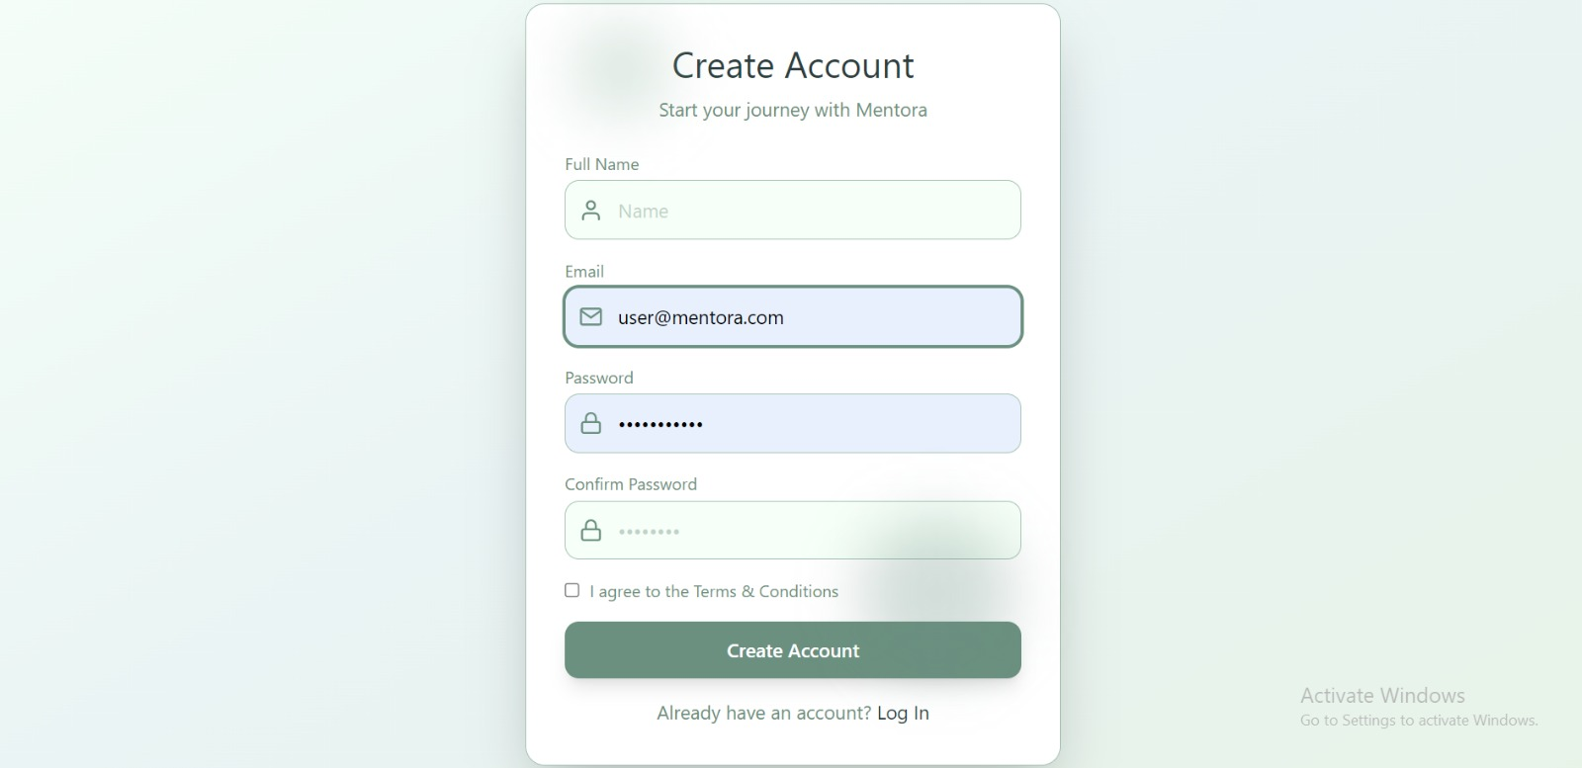
Figure 27:SignUp

    - Login Page
The login portal where you verify your identity to access your saved data.

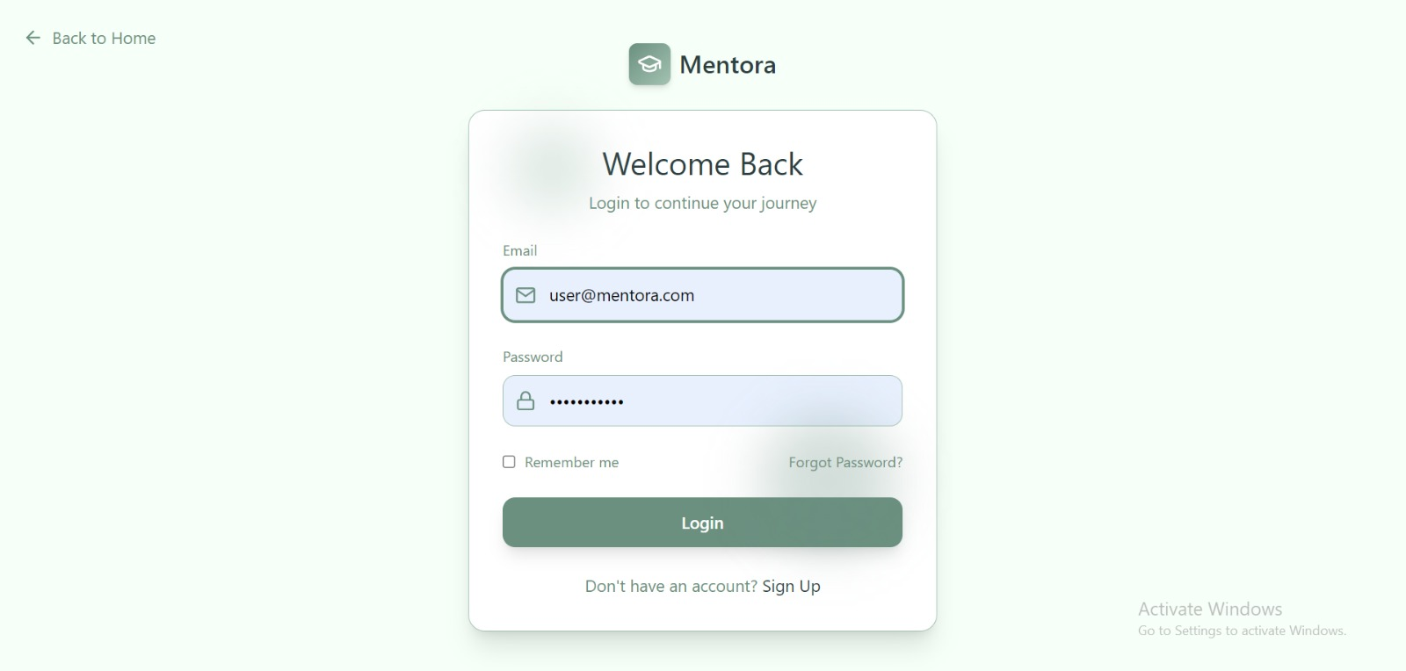
Figure 28:Login

    - Reset Password
If you lose access, this feature sends a secure link to your email to restore your account safely.

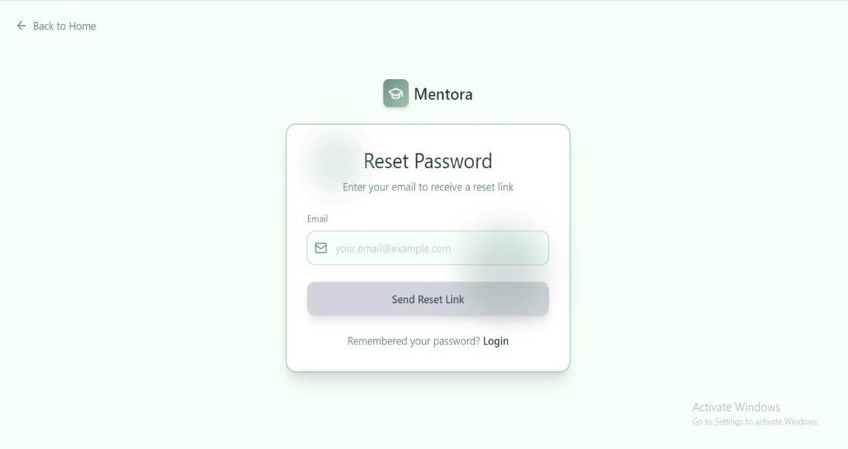
Figure 29:Reset Password

    - Personal Dashboard
This is your central command center, providing a 360-degree view of your performance.
- Performance Metrics: Track your total "Study Hours" (e.g., 124h), "Completed Tasks" (e.g., 45), and your overall "Attendance" rate (e.g., 80%).

- 7-Day Streak: A motivational fire icon that tracks how many consecutive days you have remained active in the system.

- Quick Tools: Instant access buttons for the Pomodoro Timer, AI Quiz, and Notes to help you jump straight into productivity.

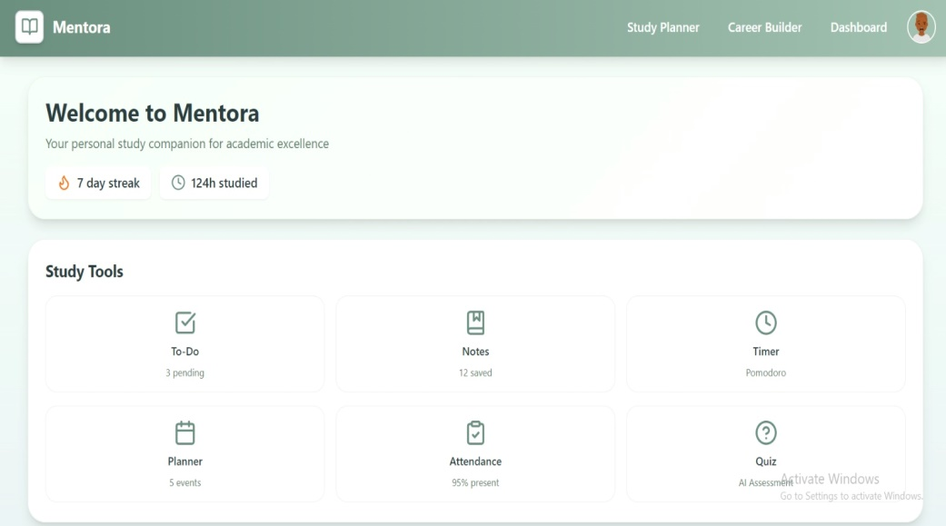
Figure 30:Dashboard
    - Study Planner
This section ensures you stay ahead of your deadlines and university requirements.
- Upcoming Events: A chronological list of your exams and labs (e.g., Math Exam, Physics Lab) pulled from the database.

- Pending Tasks: A dynamic to-do list showing your current assignments, such as "Complete Math Assignment," helping you manage your daily workload.

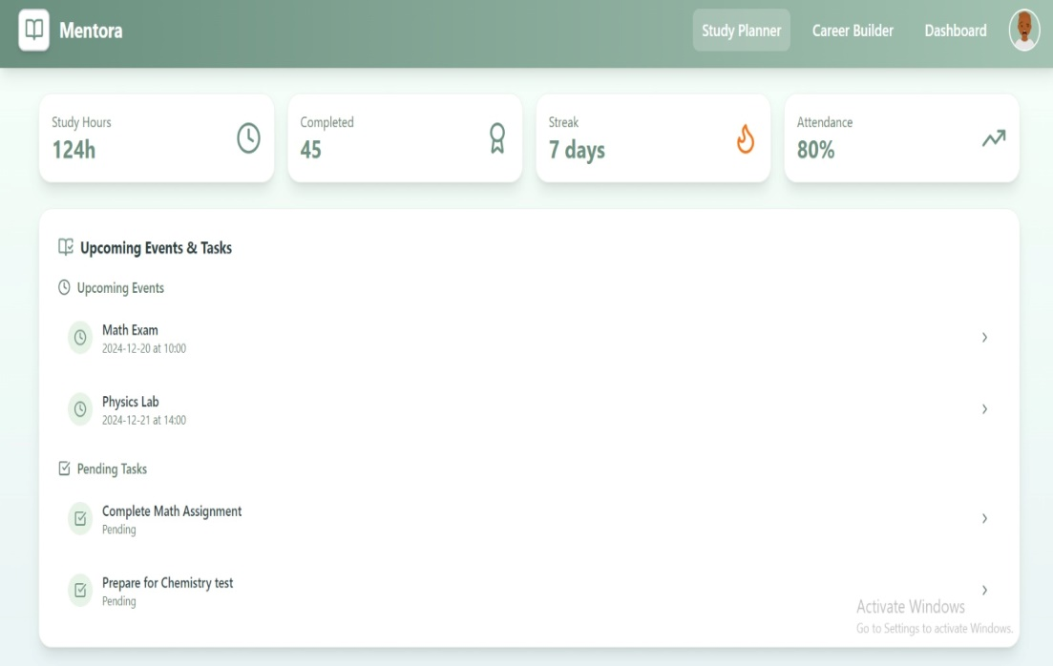
Figure 31:Study Planner

    - Career Builder & AI Intelligence
This is the specialized module where Mentora acts as your professional consultant.
- Career Plan: Access your personalized, AI-generated roadmap that outlines the specific steps needed to reach your dream job.

- Career Progress: A visual chart that measures how far you have come in your career journey based on completed milestones.

- Skills Snapshot: An analytical view of your current skill set, identifying strengths and areas that need improvement.

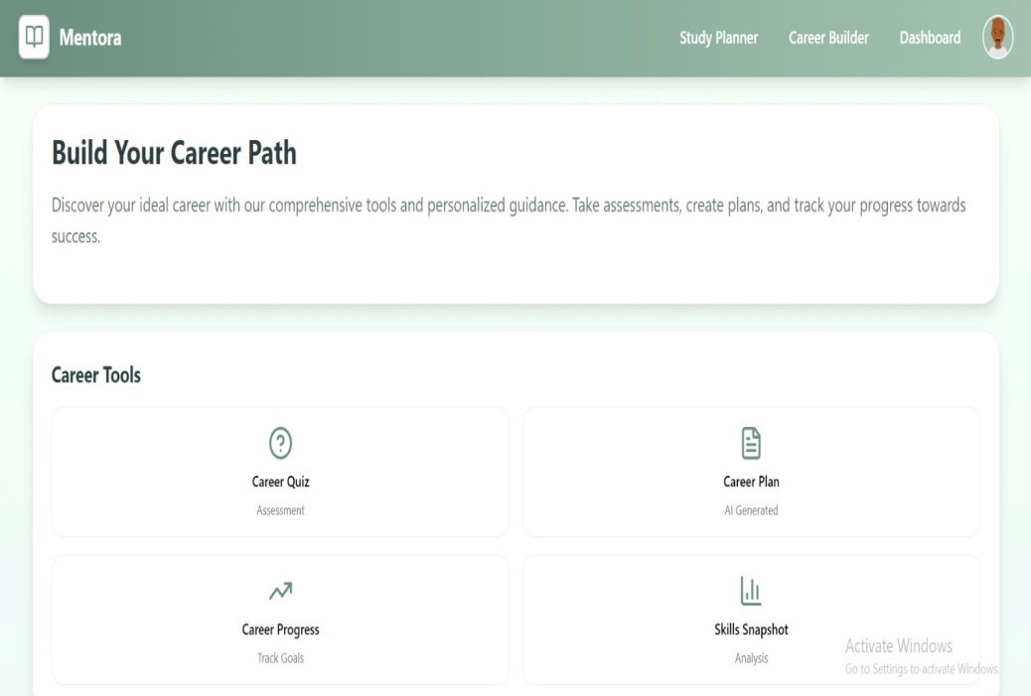
Figure 32:Career Builde
    - User Profile
Your digital identity within the Mentora community.
- Personal Bio: Displays your name (e.g., "any name"), your major (e.g., any major), and a short description of your passions.

- Contact Details: Stores your official email, phone number, and location (e.g., Amman, Jordan) for networking and profile completeness.

- Timeline: Shows your "Joined Date" to track your long-term growth since becoming a member of the platform.

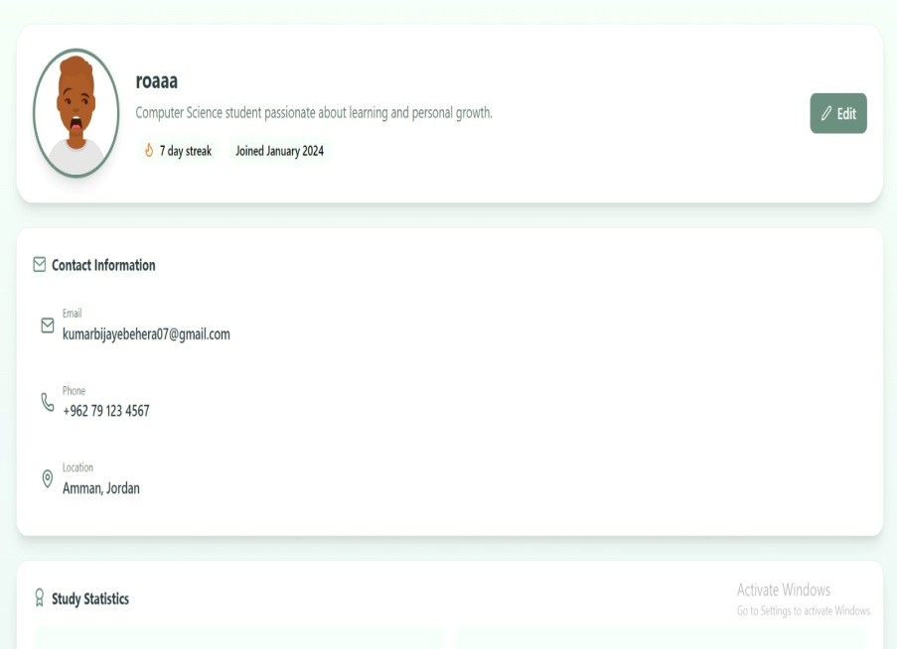
Figure 33:User Profile

  - Integration of AI / Security

To protect sensitive student data and academic records, we implemented a multi-layered security architecture.

    - AI Integration (Career Roadmap Engine)
- AI technologies (such as OpenAI) are integrated via REST API protocols to transform static student data into interactive career paths.

- Prompt Engineering: The system does not send a random question but uses structured command templates. When a student (such as Rua’a) enters her major (Computer Science) and her goal (Data Analyst), the system programmatically generates the following command:

- "As a career expert, generate a 5-step plan for a [Computer Science] major aspiring to become a [Data Analyst]. Send the response in JSON format only, matching the following tables: {Step Title, Description, Expected Duration}."

Data Processing Cycle:

- Request: The front-end sends user input to the controller.

- Processing: The server connects to the AI ​​using a hidden and secure API key.

- Data Storage: The response (JSON) is decompiled and stored directly in the CareerStep table, allowing the student to access it at any time without needing to request the plan again.

    - Security Integration (Identity & Access Management)

- To protect sensitive student data and academic records, we implemented a multi-layered security architecture.

- JWT (JSON Web Token) Implementation: Instead of vulnerable session cookies, we use JWT for stateless authentication:

- Authentication: When a user logs in, the server validates the hash of their password (using BCrypt for encryption).

- Authorization: A signed Token is sent back to the browser. For every subsequent action (like viewing the Dashboard or starting an AI Quiz), the Frontend must include this token in the Authorization: Bearer <token> header.

Database Security:
- Encryption at Rest: Sensitive information in Table 1: User (like passwords) is never stored in plain text.

- Protected Routes: Using Middleware in the backend, we ensure that a user cannot access or modify another user's StudyPlan or CareerPlan by checking the UserID embedded in the JWT.

- Input Validation: All inputs from the "Reset Password" or "Profile Edit" screens are sanitized to prevent SQL Injection and Cross-Site Scripting (XSS) attacks

  - Development Challenges
The development of a multi-layered system like Mentora presented several technical and logistical hurdles. Below are the primary challenges faced and the strategies implemented to overcome them.
- Challenge: Handling Asynchronous AI Responses

- Issue: AI APIs (OpenAI) often take several seconds to generate a full career roadmap. This caused the frontend to freeze or time out, leading to a poor user experience.

- Solution: We implemented Asynchronous Programming and Loading States in React. While the backend processes the request, the user sees a "Generating your path..." animation. Once the data is ready, the state is updated without refreshing the page.

- Challenge: Mapping AI JSON to a Relational Database

- Issue: The AI model sometimes returned inconsistent JSON structures that didn't match our SQL Server tables (CareerPlan and CareerStep), causing database insertion errors.

- Solution: We developed a Validation Middleware. This layer inspects the AI's output; if the JSON is malformed, the system automatically sends a "retry" request to the AI with stricter formatting instructions (Prompt Engineering) before attempting to save it to the database.

- Challenge: Complex Scheduling Logic (Matching Tasks to Slots)

- Issue: Creating an algorithm that matches StudyTasks to AvailabilitySlots based on "Energy Levels" was mathematically complex, especially when multiple tasks competed for the same time slot.

- Solution: We adopted a Priority-Based Sorting Algorithm. Tasks are first sorted by "Urgency" and then "Difficulty." The system then fills high-energy slots with the most difficult tasks first, ensuring the most efficient use of the student's peak performance hours.

- Challenge: JWT Token Persistence and Security

- Issue: Users were being logged out every time they refreshed the page because the authentication state was lost.

- Solution: We integrated Local Storage persistence combined with a Private Route Wrapper in React. The JWT token is securely stored and checked on every page load to restore the user session seamlessly.

- Challenge: Scope Management and Team Coordination

- Issue: With 20 database tables and multiple modules (Gamification, AI, Scheduler), managing the project scope within the deadline was difficult.

- Solution: We utilized Agile Methodology. We broke the project into "Sprints," focusing first on the core Authentication and AI Roadmap (MVP) before moving to secondary features like Badges and Streaks.

Chabter 6:
TESTING

  - Types of Testing

Building stable and usable software was greatly helped by testing. Throughout the project, heavy reliance on testing ensured the application works as expected, from small components to the full user experience. The goal was to catch issues early, maintain stability, and ensure the system meets both functional requirements and user expectations.
To achieve this, a multi-layered testing strategy was implemented. Unit testing, integration testing, and system testing were conducted to validate the complete application's expected behavior. End-to-end (E2E) testing was also performed.
By combining these different testing methods, confidence in the quality of the application was built, and features were able to be developed more safely and efficiently.

- Unit Testing:
focuses on testing individual components or functions of the system in isolation. Each unit is tested separately to ensure it performs its intended functionality correctly.

Example in Mentora:

- Testing individual backend API methods such as user registration, login validation, or AI request handling.

- Verifying frontend components like form validation or input handling.

Purpose:
- Detect errors early in development.
- Ensure correctness of small units of code.

- Integration Testing:
verifies that different system modules work together correctly after being combined. It focuses on the interaction between components rather than individual units.

Example in Mentora:

- Testing the integration between the React frontend and the ASP.NET Core backend.

- Verifying correct data flow between the backend and the OpenAI API.

- Ensuring JWT authentication works correctly between client and server.

Purpose:

- Identify interface and communication issues.
- Ensure data is passed correctly between modules.

- System Testing
evaluates the complete and fully integrated system as a whole. It ensures that the system meets both functional and non-functional requirements.

Example in Mentora:

- Testing the full user workflow from login to generating and saving career or study plans.

- Verifying performance, security, and usability requirements.
- Checking error handling and system stability.

Purpose:

- Validate the overall behavior of the system.
- Ensure compliance with project requirements.

- User Acceptance Testing (UAT)
is performed to verify that the system satisfies user needs and expectations. It is usually conducted by end users or stakeholders.

Example in Mentora:

- Allowing students to use the platform and generate career and study plans.
- Collecting feedback on usability, clarity of AI-generated recommendations, and overall experience.
Purpose:
- Confirm the system is ready for deployment

- Ensure the system meets real-world user expectations

  - Test Cases and Results
This section presents the test cases executed on the Mentora system to validate its core functionalities. Each test case includes the input data, expected output, actual result, and test status.
Test Case ID | Feature | Input | Expected Output | Actual Result | Status
TC-01 | User Login | Valid email and correct password | User logs in and dashboard is displayed | User logged in successfully | Pass
TC-02 | User Login | Valid email and incorrect password | Error message displayed | Error message shown correctly | Pass
TC-03 | Career Builder | Career goals, skills, time constraints | AI-generated career roadmap | Career plan generated successfully | Pass
TC-04 | Study Planner | Subjects, available time, study duration | Optimized weekly study schedule | Study plan generated correctly | Pass
TC-05 | Save Plan | Click “Save Plan” | Plan saved in database | Plan saved successfully | Pass
TC-06 | Security (JWT) | Access protected page without token | Access denied | Access denied correctly | Pass
TC-07 | Logout | Click “Logout” | User logged out and redirected to login page | User logged out successfully | Pass
Table 21:Test cases

  - Performance Evaluation
This section evaluates the performance of the Mentora system based on several key metrics, including response time, system load time, and reliability. The goal is to ensure that the system meets the defined performance and usability requirements.
Performance Metrics Used
The following metrics were used to evaluate system performance:
- Page load time.
- AI response time.
- Authentication response time.
- System reliability under normal usage.

Metric | Description | Measured Value | Expected Value | Status
Page Load Time | Time to load main pages (Login/Dashboard) | 1.8 seconds | ≤ 3 seconds | Pass
AI Response Time | Time to generate career/study plans | 6–8 seconds | ≤ 10 seconds | Pass
Login Response Time | Time to authenticate user | < 1 second | ≤ 2 seconds | Pass
API Response Time | Backend API request processing | ~700 ms | ≤ 1 second | Pass
System Stability | Errors during normal usage | No crashes detected | No crashes | Pass
Table 22:Metrices
  - Security Testing
Security testing was conducted to ensure that the Mentora system protects user data, prevents unauthorized access, and complies with basic security requirements. The focus was on authentication, authorization, data protection, and vulnerability prevention.
The following security testing methods were applied:

- Authentication Testing: Verifying that only registered users can access the system using valid credentials.

- Authorization Testing: Ensuring that users cannot access resources that do not belong to them.

- Input Validation Testing: Testing system resistance against invalid or malicious inputs.

- Session Management Testing: Verifying the correct handling of JWT tokens.

- Penetration Testing (Basic Level):
Basic penetration testing was performed manually by simulating common attack scenarios:
- Attempting to access protected pages without a valid JWT token.
- Modifying API requests to access other users’ data.
- Trying multiple incorrect login attempts to verify error handling.
- Result:
All unauthorized access attempts were blocked successfully, and the system responded with appropriate error messages.
- vulnerability Testing:
The system was tested for common vulnerabilities:

- SQL Injection: User inputs were tested with malicious SQL commands.
- Cross-Site Scripting (XSS): Script injections were attempted in text input fields.
- Token Tampering: JWT tokens were modified to test session validation.
Result:
No critical vulnerabilities were detected. All inputs were properly validated and sanitized by the backend.

  - Tools Used
Several tools were utilized during the testing and evaluation phase of the Mentora project to ensure system functionality, performance, and security.
- Postman
was used to test and validate backend RESTful APIs. It helped verify correct request handling, response formats, authentication using JWT tokens, and error responses.
Usage in Mentora:
- Testing login and registration APIs.
- Validating AI request endpoints.
- Testing secured routes with and without JWT tokens.
- Browser Developer Tools
Built-in browser developer tools (such as Chrome DevTools) were used to test frontend behavior and performance.
Usage in Mentora:
- Inspecting HTTP requests and responses.
- Measuring page load time and network performance.
- Debugging JavaScript errors.

- Manual Testing
Manual testing was conducted to verify user workflows and overall usability.
Usage in Mentora:
- Testing complete user journeys
(login → generate plan → save plan).
- Validating UI interactions and error handling.
- User Acceptance Testing (UAT).
- Logging and Monitoring Tools
Backend logging tools were used to track system behavior and detect errors during runtime.
Usage in Mentora:
- Monitoring API request failures
- Logging AI response success or failure
- Identifying performance bottlenecks

